**Part3**

1. Write a query to display the current date. Label the column “Date”.



1. 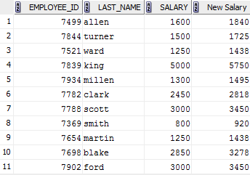For each employee, display the employee number, last_name, salary and salary increased by 15% and expressed as a whole number. Label the column New Salary.
2. Modify the previous query by adding a column that subtract the old salary from the new salary. Label the column “Increase”.

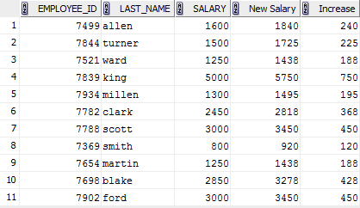

1. **Advanced**:

For each employee display the employee’s last name and calculate the number of month between today and the date the employee was hired. Label the column MONTH_WORKED. Order your results by the number of month employed. Round the number of month up to the closest whole number.

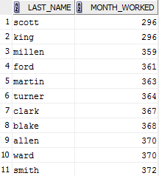

1. Write a query that produces the following for each employee:

*<employee last name> earns <salary> monthly but wants <3 times salary>*.

Label the column “Dream Salaries”.

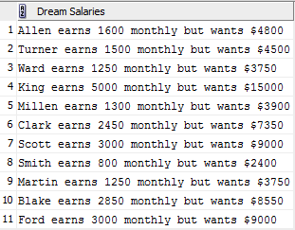

1. Create a query to display the last name and salary for all employees. Format the salary to be 15 characters long, left-padded with $. Label the column “Salary”.

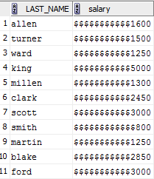

1. **Advanced**: Create a query that displays the employees last names and indicates the amounts of their annual salaries with asterisks. Each asterisk signifies a hundred dollars. Sort the data in descending order of salary. Label the column EMPLOYEES_AND_THEIR_SALARIES.

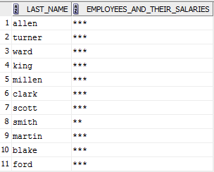

1. **Advanced**: Using the DECODE function, write a query that displays the grade of all employees based on the value of the function JOB_ID, as per the following data:

*Job* *Grade*

President A

Salesman B

Clerk C

Manager D

None of above 0

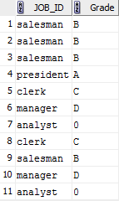

**GROUP FUNCTIONS**

1. Display the highest, lowest, sum, and average salary of all employees. Label the columns “Maximun”, “Minimum”, “Sum” and “Average”. Round your results to the nearest whole number.



1. Modify the previous query to display the minimum, maximum, sum and average salary for each job type.

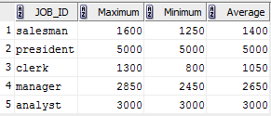

1. 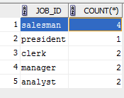Advanced. Write a query to display the number of people with the same job.
2. Determine the number of managers without listing them. Label the column “Number of Managers”.



1. Write a query that displays the difference between the highest and the lowest salaries. Labek the column “Difference”.

